EXPERIMENT 13

13.1.1//Fibonacci sequence using module
Ans:ALGORITHM:

FLOWCHART:
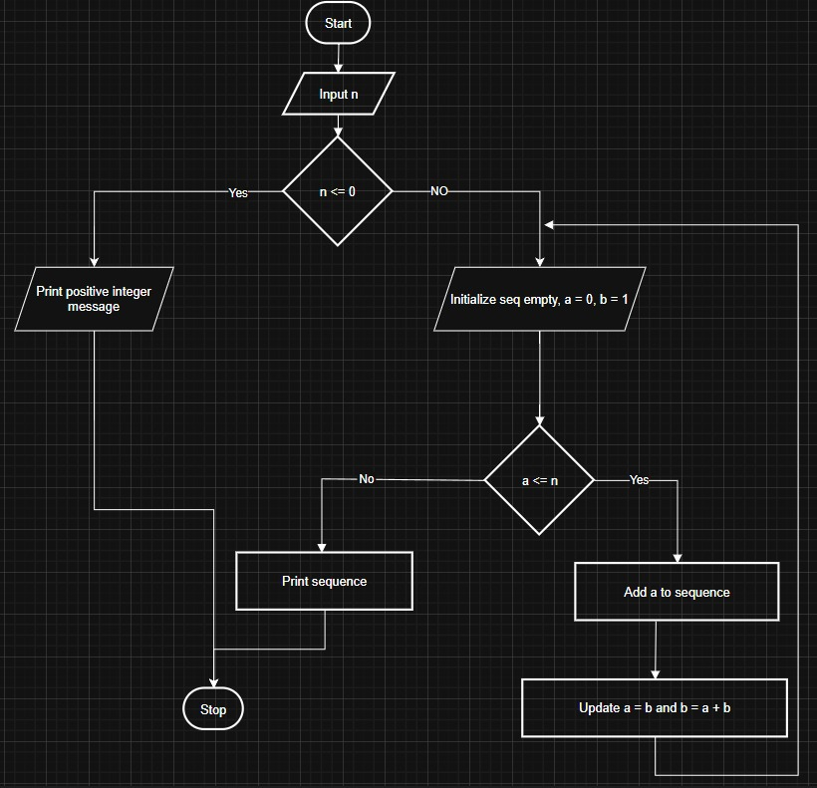

CODETANTRA:
